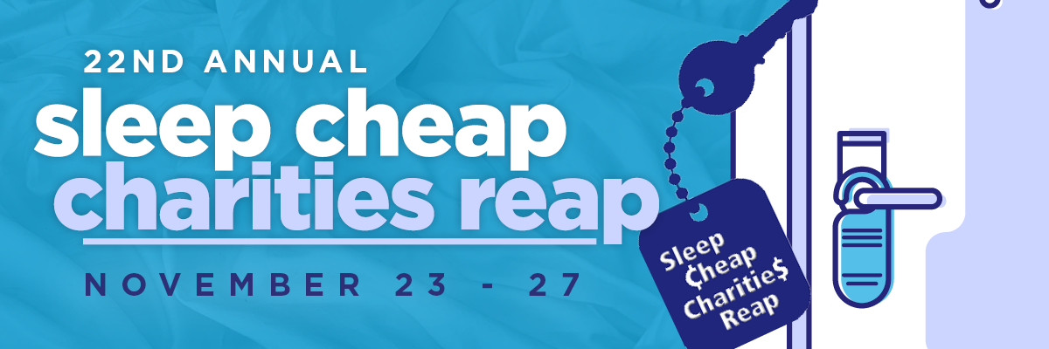

Sleep Cheap Charities Reap 2025: Application for Donation

Please complete the following application. If more space is required, use additional paper.

APPLICATION FOR DONATION
Date of Application:
Name of Registered Charitable Organization or Registered Not-for-Profit:
Mailing Address:
Street Address (if different from Mailing Address above):
Telephone:
Fax:
Email:
Contact Name:
Website (if applicable):
Charitable or Not-for-Profit Registration Number:
Date of Incorporation:
Number of Full-Time Employees:
Number of Part-Time Employees:
Number of Volunteers:
Amount of Request:
Is this your first request to the Sleep Cheap Committee?

Sleep Cheap Charities Reap 2025: Application for Donation (con’t)
Please complete the following application form. If more space is required, use additional paper.

In the space below, please succinctly respond to the following:

What is the mandate of your organization, including activities/programs offered? (please attach additional information as appropriate).

What segment of the population does your organization serve or benefit in Niagara Falls? Provide statistics indicating the number of Niagara Falls residents impacted by your service or program.

Describe in detail how your organization intends to use the funds requested from Sleep Cheap Charities Reap.
- What will happen as a result of the requested donation? How would this donation make a difference to your organization, and to the residents of Niagara Falls?

List the types and levels of funding your organization currently receives. Please list any funding your organization receives from the City of Niagara Falls and provide the percentage of your funding that comes from local grassroots fundraising.
- Please indicate whether this is a capital or operating fund request.

I confirm that the information contained in this application is true and accurate to the best of my knowledge.

Print Name:

Signature of Senior Staff Person:

Print Name:

Signature of Chairperson or Board Representative:

Submission Deadline – Thursday, November 27, 2025 - 12:00 noon

Note: Please be aware that we receive far more requests than we are able to support at one time and that a decision not to support does not necessarily reflect on the merit of the request.

